BPEL4Chor Datamodel Development Manual
Last update: 2012-10-15
Daojun Cui
This document is an extract of all documentation about the projects developed within the diploma thesis “Splitting BPEL Processes”.
The documentation of the project, where a BPEL process is split to a BPEL4Chor choreography is available at the BPEL-splitting project.

This documentation is also covered by the Apache 2.0 license.

Table of Contents
1 Development environment 3
1.1 Working Environment 3
1.2 Prerequisites for Running Eclipse BPEL Designer 3
1.3 Setup the Working Environment 3
1.3.1 Installation of JDK 1.6.x (32 bit) 4
1.3.2 Installation of Eclipse JEE (32 bit) 4
1.3.3 Installation of Plug-In EclEmma for Eclipse (optional) 4
1.3.4 Installation of TortoiseGit 4
1.3.5 Download Source Projects of Eclipse BPEL Designer with TortoiseGit 5
1.3.6 Download the Prerequisites and Unzip them in Eclipse-Dir 10
1.3.7 Import Source Projects of Eclipse BPEL Designer 10
1.3.8 Import the Dependent Projects for Splitting Processes 14
1.3.9 Verification of the Setup 18
1.3.10 Some Import for post-installation 19
1.4 Run BPEL Designer from Source Code 23
1.4.1 First way – Use the Configured Run Configuration 23
1.4.2 Second way – Create a new configuration yourself 26
2 Reading and Writing of BPEL and WSDL 35
2.1 Initialization of BPELPlugin 35
2.2 Reading and Writing BPEL 35
2.2.1 Reading BPEL 35
2.2.2 Writing BPEL 35
2.3 Reading and Writing WSDL 36
2.3.1 Reading WSDL 36
2.3.2 Writing WSDL 37
3 BPEL4Chor Model 38
3.1 Project Specification 38
3.2 BPEL4Chor Choreography Artifacts 38
3.2.1 Grounding 38
3.2.2 Topology 39
3.2.3 Participant Behavior Description (PBD) 39
3.3 BPEL4Chor Model 40
3.3.1 Model Diagram 40
3.3.2 Class Diagram 41
3.3.3 BPEL4Chor Reader and Writer Architecture 42
3.3.4 BPEL4Chor Utility 44
3.4 Project Metrics 45
4 BPEL4Chor Model Test 46
4.1 Project Specification 46
4.2 Project Metrics 47

Development environment

Working Environment
Nr. | Category | Description
1 | System | Windows XP SP3, Windows 7 Pro. 64 Bit
2 | Java | JDK 1.6.26 32bit
3 | Programming IDE | Eclipse Helios SR2 32 bit
4 | BPEL Library | Eclipse BPEL Designer Source Code version M0.5
5 | XML Library | StAX, JAXB, DOM
6 | Command Line Interface Library | Args4j
7 | Graph Library | JGraphT up-to-date version
8 | Test Tools | Junit 4(Unit Test), EclEmma Plugin in Eclipse(Code Coverage for Test)
9 | Log Library | log4j

Prerequisites for Running Eclipse BPEL Designer
The eclipse BPEL designer is currently(Stand 2012-06) at milestone v1.0. It requires min. JDK 1.6. As writing this document the BPEL designer is tested with Eclipse Helios SR2 + JDK 1.6.x(32bit).
The following projects is needed for BPEL development
- org.eclipse.bpel.common.model
- org.eclipse.bpel.common.ui - Common UI classes are here.
- org.eclipse.bpel.model - The BPEL model classes generated from the EMF model, resource sets, etc.
- org.eclipse.bpel.wsil.model - The WSIL model we use in the WSIL browser.
- org.eclipse.bpel.ui - The main editor code.
- org.eclipse.bpel.runtimes - This is what runtimes need to extend in order to plug in.
- org.eclipse.bpel.apache.ode.runtime - A Reference integration with the Apache ODE runtime.
- org.eclipse.bpel.apache.ode.deploy.ui - An Editor to create an Apache ODE deployment descriptor.
- org.eclipse.bpel.apache.ode.deploy.model - The EMF model for the deployment descriptor editor.
- org.eclipse.bpel.validator - A BPEL validator that will check the BPEL source for errors.
- org.eclipse.bpel.examples.extensionPoints - Some examples of extension points provided by other plugins in the BPEL editor.
You can check out the plug-in projects from https://git.eclipse.org/c/bpel/org.eclipse.bpel.git/
One can find the source projects in the checked-out folder org.eclipse.bpel/plugins.
After that just import them into the workspace where you put the org.bpel4chor.splitprocess project.
Note that it is better also to install the BPEL Designer into your eclipse installation. The simplest way is the BPEL Editor Update Site . It will provide some bundles that the configuration lacks.

Setup the Working Environment
This section introduces how to setup a working environment for the projects of splitting BPEL processes.

Installation of JDK 1.6.x (32 bit)
Download Link: http://www.oracle.com/technetwork/java/javase/downloads/jdk-6u25-download-346242.html
Choose and download the JDK x86 version for 32 bit and install.

Installation of Eclipse JEE (32 bit)
Download Link: http://www.eclipse.org/downloads/
Choose the JEE version, and the version must be >= Helios SR2

Installation of Plug-In EclEmma for Eclipse (optional)
Download Link: http://www.eclemma.org/installation.html – follow the installation instructions

Installation of TortoiseGit
Download Link: http://code.google.com/p/tortoisegit/downloads/list – choose the up-to-date 32 bit version

Download Source Projects of Eclipse BPEL Designer with TortoiseGit
Step 1
Check out https://git.eclipse.org/c/bpel/org.eclipse.bpel.git/
to our local directory for instance D:\download\source\
Select “Get Clone” ==>
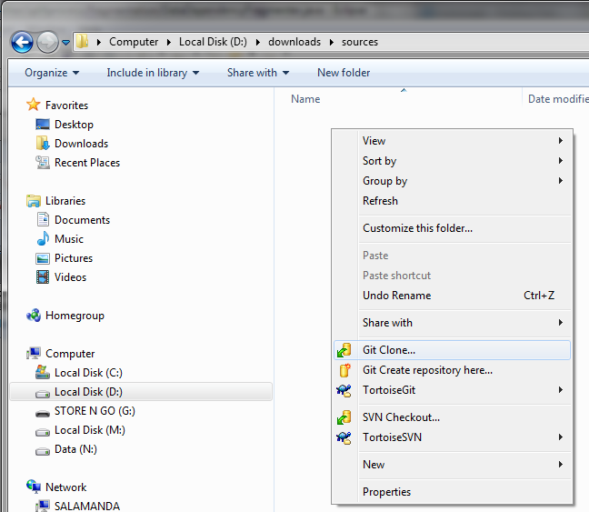

Setp 3
Url: https://git.eclipse.org/c/bpel/org.eclipse.bpel.git/
Click Ok
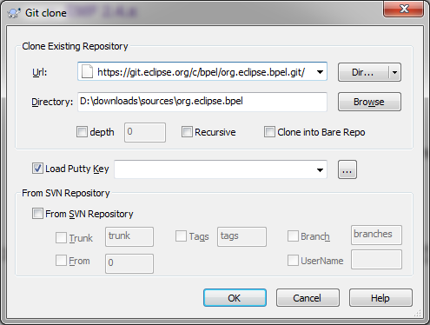

Setp 4
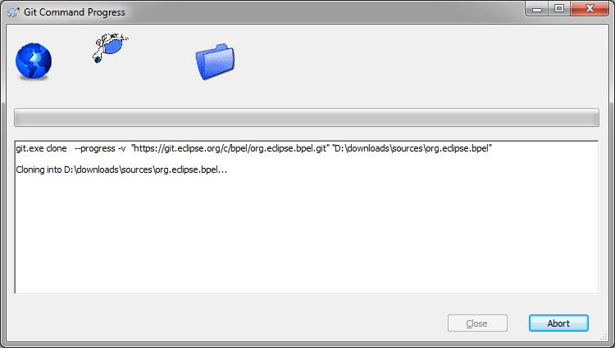

Step 5
The source projects are now in the sub-directory org.eclipse.bpel/plugins/
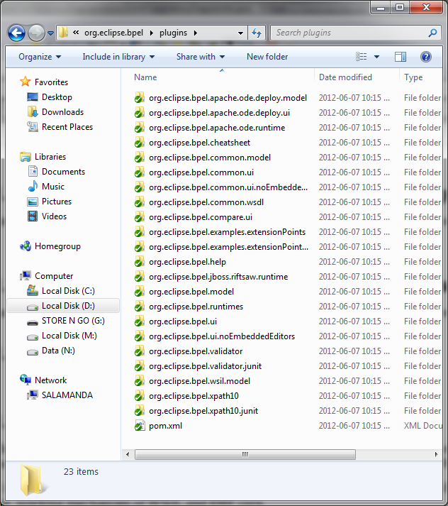

Download the Prerequisites and Unzip them in Eclipse-Dir

EMF 2.6.x
http://archive.eclipse.org/modeling/emf/emf/downloads/drops/2.6.x/R201009141218/
Select the emf-xsd-SDK-2.6.1.zip
After download unzip it into [Path/to/eclipse]/

GEF 3.6.x
http://www.eclipse.org/gef/downloads/?showAll=1&hlbuild=R201102251600&project=gef#R201102251600
Select the All-One-SDK GEF-ALL-3.6.2.zip
After download unzip it into [Path/to/eclipse]/

EMF Compare 1.2
http://www.eclipse.org/emf/compare/downloads/
Select the Releases 1.2.2 emf-compare-SDK-1.2.2.zip

GMF 2.1.3
http://archive.eclipse.org/modeling/gmf/gmf/downloads/drops/2.1.3/R200902181028/
Select the gmf-2.1.3-sdk.zip

DTP STK
Data Tool Platform is contained in Eclipse JEE Version

WTP (Web Tools Platform)
Web Tool Platform is contained in Eclipse JEE Version

Import Source Projects of Eclipse BPEL Designer
Assume that the workspace directory is D:\workspaces\workspace-splitting-process
Step 1 – Select menu File - > Import - > Existing Projects into Workspace - > Next
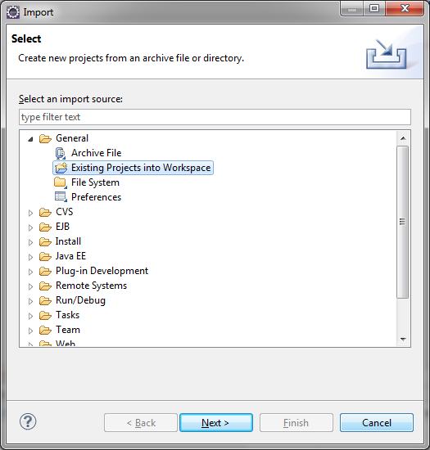

Step 2
- Root directory “D:\downloads\sources\org.eclipse.bpel\plugins” or where you put the checked-out sources code
- Make sure the “copy into workspace” is checked.
- Select All and Click Finish
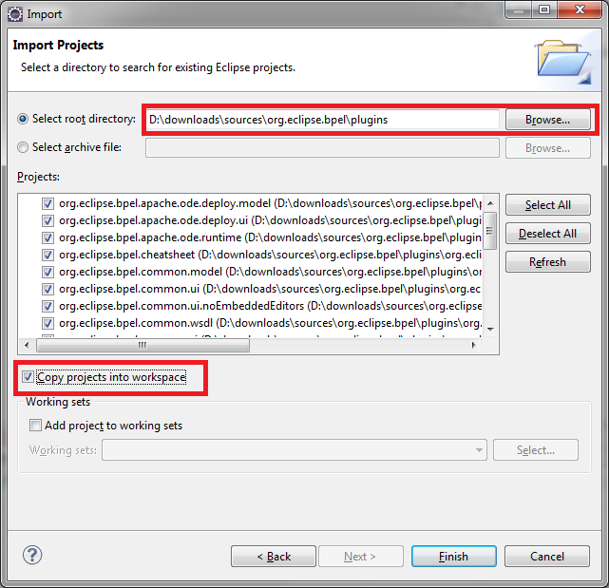

Step 3
After the import, some project will show errors.
- make sure the JDK is configured in the “Windows - > Preferences - > Java - > Installed JRE”
- close the unnecessary project “org.eclipse.bpel.compare.ui”
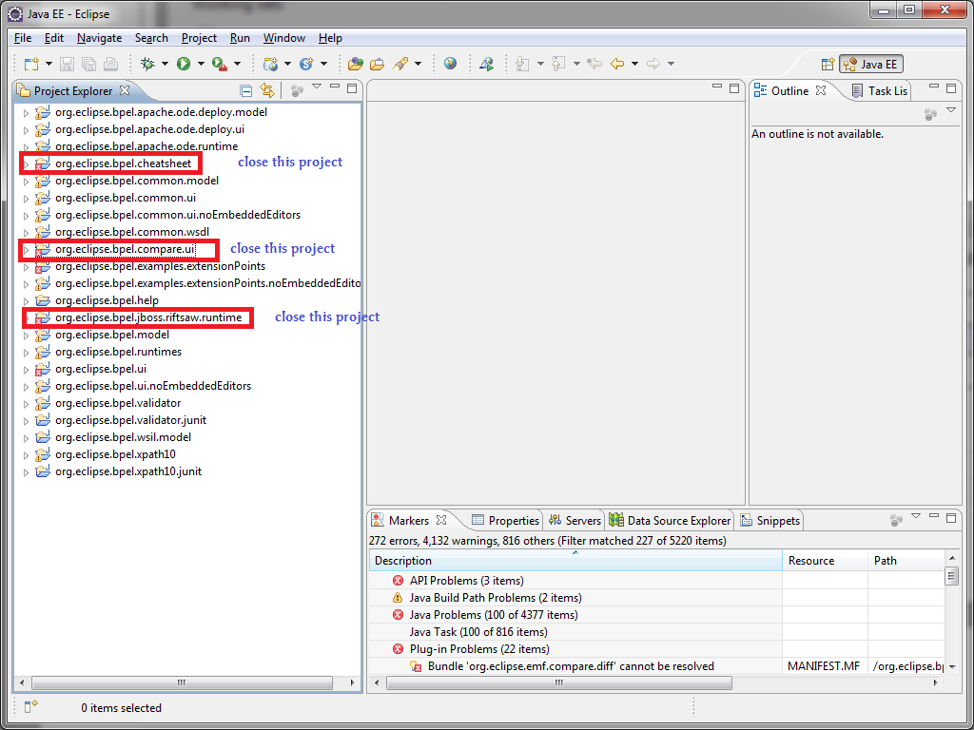

Step 4
Make sure ALL the project IDs in the MANIFEST.MF are identical to the project names
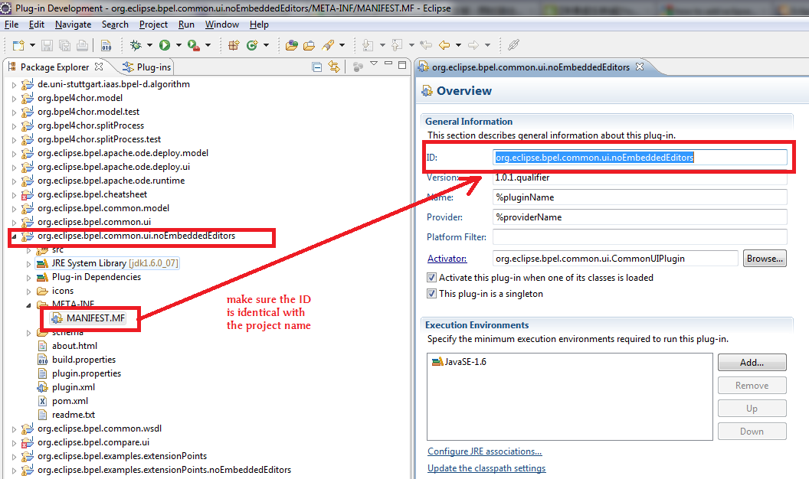

Import the Dependent Projects for Splitting Processes
Assume that the workspace directory is D:\workspaces\workspace-splitting-process

Import Data-Flow Analysis Projects using SVN

This part is outdated. The dataflow analysis project is now also available via git:
https://github.com/IAAS/BPEL-dataflow-analyzer
Step 1 - Check out the source from:
https://svn.flupp.de/BPEL-D/code/BPELDataFlowAnalyzer/trunk/src/de.uni-stuttgart.iaas.bpel-d.algorithm
into workspace
==>Click Ok
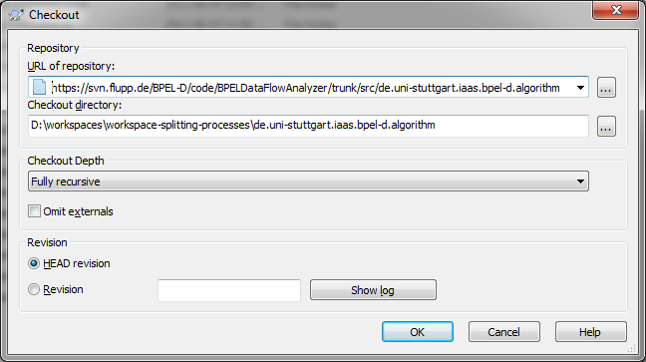

Step 2 - The checked-folder is in D:\workspaces\workspace-splitting-process
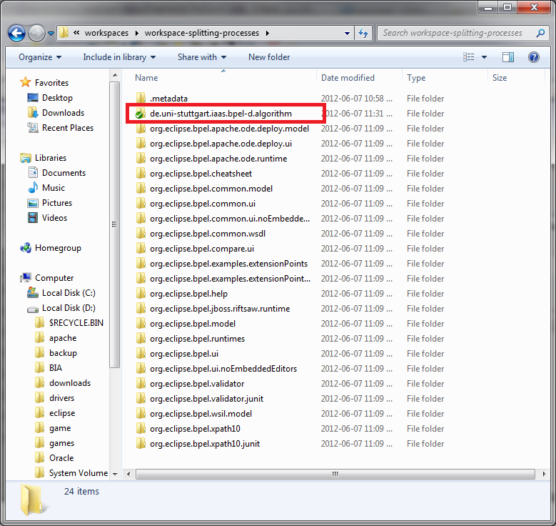

Step 3 – import the project in eclipse
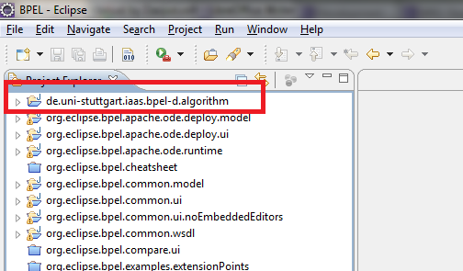

Import Projects for Splitting Processes using SVN
Step 1 – check out the projects under
https://svn.flupp.de/BPEL-D/code/splitting/trunk/src/ in the workspace and import in eclipse
1) org.bpel4chor.model
2) org.bpel4chor.model.test
3) org.bpel4chor.splitprocess
4) org.bpel4chor.splitprocess.test
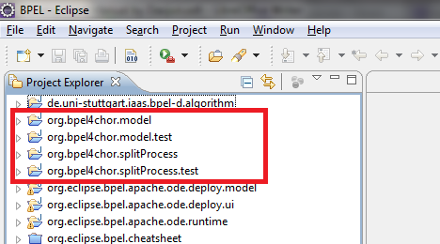

Verification of the Setup
Navigate to org.bpel4chor.splitprocess.test/src/org.bpel4chor.splitprocess.test.AllTests.java
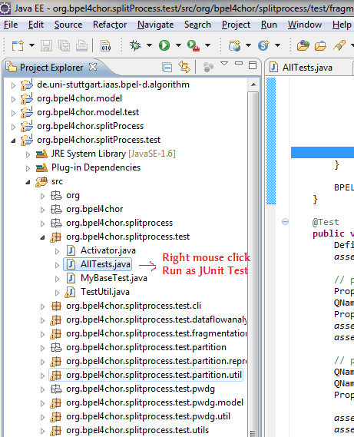

If the JUnit Test ended successfully, the setup is valid.
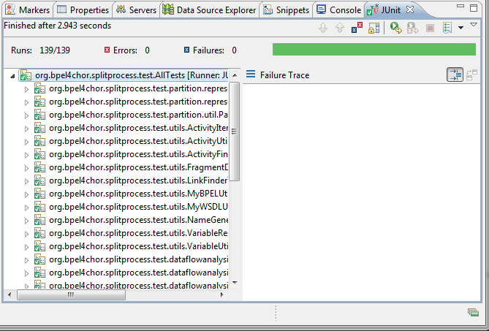

Some Import for post-installation
The BPEL project source code is based on the WSDL source code, and the WSDL source code is based on the EMF model. This section introduces how to import the source code of the dependent WSDL projects and EMF projects.
It is not mandatory to import them for splitting BPEL processes, but it is helpful if you do want to know more about the working mechanism of WSDL and EMF core.
Getting the source code of the Web Tools Platform
http://www.eclipse.org/webtools/community/tutorials/DevelopingWTP/DevelopingWTP.html

Switch to the CVS Repository Perspective - > Right Mouse Click - > New CVS Repository
Host: dev.eclipse.org
Repository path: /cvsroot/webtools
User: anonymous
Password:
Connection Type: pserver
=> Click Finish
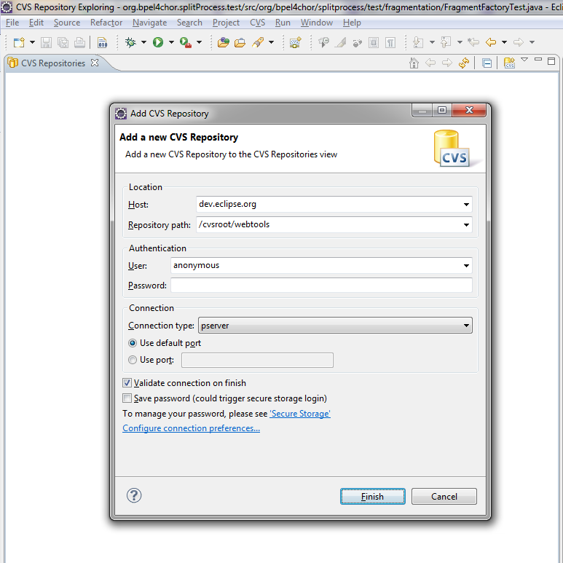

Navigate to project : org.eclipse.wst.wsdl
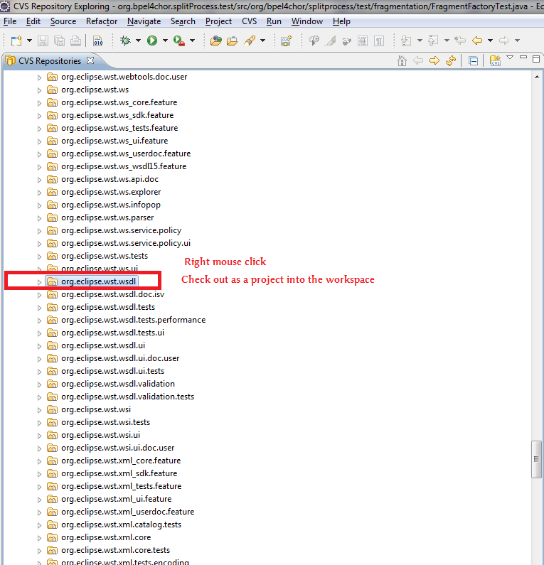

Click Finish
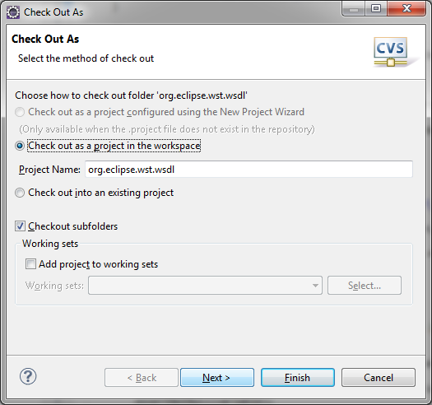

The project will be imported into the project explorer
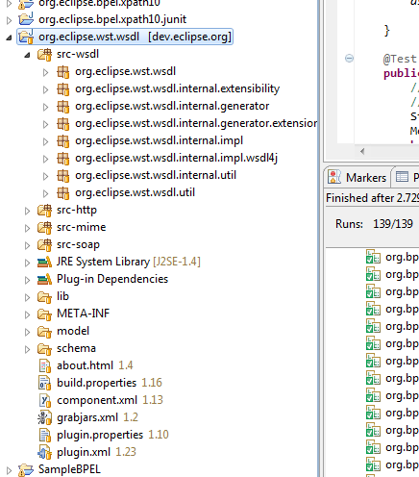

Run BPEL Designer from Source Code
Before you run, make sure you have selected a 32-bit JDK1.6.x for the BPEL designer.

First way – Use the Configured Run Configuration
It is assumed you have properly imported the project org.bpel4chor.splitProcess and its dependencies.

The steps:

Step 1.
Navigate to Package Explorer in Eclipse, unfold the project org.bpel4chor.splitProcess

Step 2
Right mouse click on bpel-designer-with-split-process.launch => Select Run as => Select bpel-designer-with-split-process =>

Step 3.
Then you will see =>
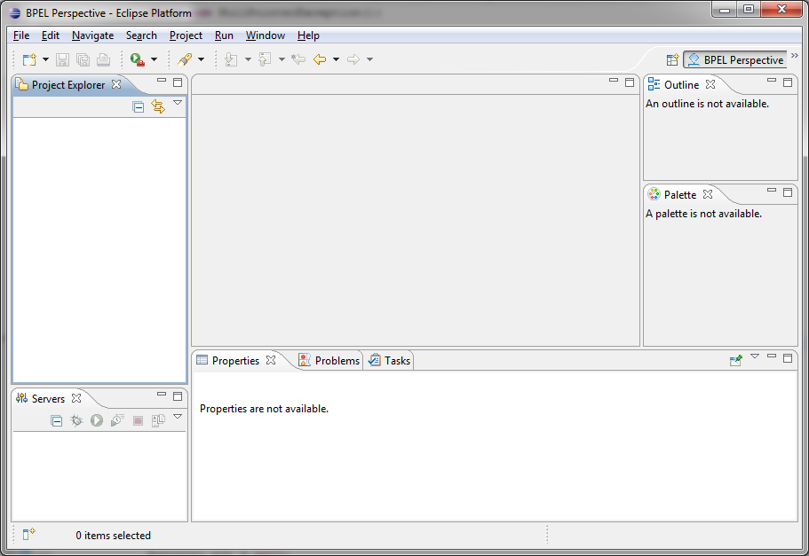

Second way – Create a new configuration yourself

Steps:
Step 1. Select Menu in Eclipse: Run->Run Configurations=> Select Eclipse Application in the left column => click the 'New' button=>

Step 2.
Select Main Tab in the configuration window:
- Program to Run: leave the default
- Java Runtime Environment: make sure you select the 32-bit JDK1.6.x

Step 4.
Select Plug-ins Tab in the configuration window
- Launch with: select the option - “plug-ins selected below only”
- Select the plug-ins in the workspace we want
- Deselect all the Target Platform first =>

Step 5.
Click the “Add Required Plug-ins” at the right column inside of the Plug-ins Tab

Step 6.
Then we will see the dependencies have been taken care of =>

Step 7.
One last thing to do, check on the javax.wsdl 1.5.1, if it is not checked, do it manually.

Step 8.
If you want to share this configuration in a config file, do it in the “Common” tab

Step 9.
Click Button “Apply” at down side
Click Run =>
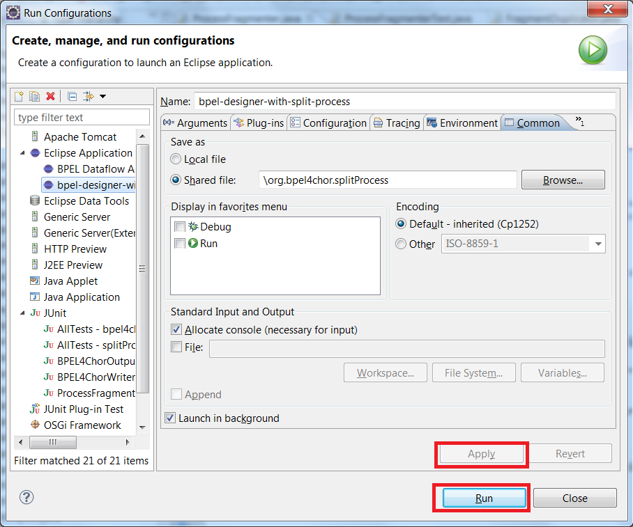

Step 10. Result
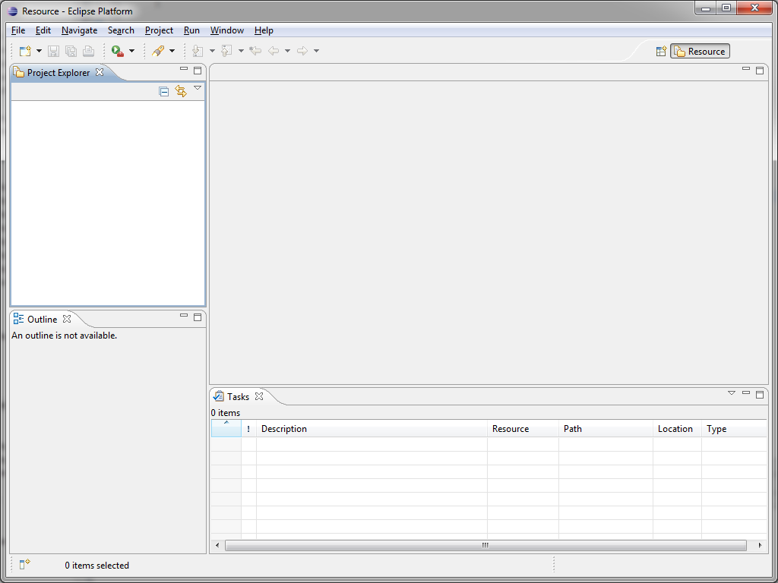

Reading and Writing of BPEL and WSDL
The reading and writing of BPEL and WSDL files are common tasks of projects. So they are separately introduced here.

Initialization of BPELPlugin
It is mandatory to initialize the BPELPlugin before you do any reading or writing to the BPEL or WSDL files without starting a Eclipse Workbench.
Source: https://svn.flupp.de/BPEL-D/code/splitting/trunk/src/org.bpel4chor.model/org.bpel4chor.utils.MyBPELReader
static {
// init
BPELPlugin bpelPlugin = new BPELPlugin();
// setup the extension to factory map, so that the proper ResourceFactory can be used to read the file.
Resource.Factory.Registry.INSTANCE.getExtensionToFactoryMap().put("bpel", new BPELResourceFactoryImpl());
Resource.Factory.Registry.INSTANCE.getExtensionToFactoryMap().put("wsdl", new WSDLResourceFactoryImpl());
Resource.Factory.Registry.INSTANCE.getExtensionToFactoryMap().put("xsd", new XSDResourceFactoryImpl());
}

Reading and Writing BPEL

Reading BPEL
Source: http://www.eclipse.org/bpel/developers/model.php Section: Reading and Writing BPEL Files
ResourceSet resourceSet = new ResourceSetImpl();
URI uri = URI.createFileURI(strURI);
boolean loadOnDemand = true;
Resource resource = resourceSet.getResource(uri,loadOnDemand);
Process process = (Process) resource.getContents().get(0);

Writing BPEL
Szenario: The BPEL process is read from a BPEL file
call resource.save()

Szenario: The BPEL process is created in runtime, it does not present in any BPEL file yet., We want to print the BPEL process in the console

Source: https://svn.flupp.de/BPEL-D/code/splitting/trunk/src/org.bpel4chor.splitprocess.utils.MyBPELUtils.print(Process)
// init
BPELPlugin bpelPlugin = new BPELPlugin();
Resource.Factory.Registry.INSTANCE.getExtensionToFactoryMap().put("bpel", new BPELResourceFactoryImpl());
Resource.Factory.Registry.INSTANCE.getExtensionToFactoryMap().put("wsdl", new WSDLResourceFactoryImpl());
Resource.Factory.Registry.INSTANCE.getExtensionToFactoryMap().put("xsd", new XSDResourceFactoryImpl());

boolean useNSPrefix = false;
ResourceSet resourceSet = new ResourceSetImpl();
// "any.bpel" is only a work-around to bypass the need of URI in BPELResource
URI uri = URI.createFileURI("any.bpel");
BPELResource resource = (BPELResource) resourceSet.createResource(uri);
resource.setOptionUseNSPrefix(useNSPrefix);
resource.getContents().add(process);

Map argsMap = new HashMap();
// this args map prevents a NPE in the release 1.0
argsMap.put("", "");
resource.save(System.out, argsMap);

Szenario: The BPEL process has been created in run-time, it is not present in any BPEL file yet. We want to write the BPEL process to a BPEL file

Source: https://svn.flupp.de/BPEL-D/code/splitting/trunk/src/org.bpel4chor.utils.BPEL4ChorWriter.writeBPEL(Process, OutputStream)
// init
BPELPlugin bpelPlugin = new BPELPlugin();
Resource.Factory.Registry.INSTANCE.getExtensionToFactoryMap().put("bpel", new BPELResourceFactoryImpl());
Resource.Factory.Registry.INSTANCE.getExtensionToFactoryMap().put("wsdl", new WSDLResourceFactoryImpl());
Resource.Factory.Registry.INSTANCE.getExtensionToFactoryMap().put("xsd", new XSDResourceFactoryImpl());

ResourceSet resourceSet = new ResourceSetImpl();
URI uri = URI.createFileURI("any.bpel");
BPELResource resource = (BPELResource) resourceSet.createResource(uri);
resource.getContents().add(process);
Map argsMap = new HashMap();
argsMap.put("", "");// this args map prevents a NPE in the release 1.0
resource.save(outputStream, argsMap);

Reading and Writing WSDL

Reading WSDL
Source: https://svn.flupp.de/BPEL-D/code/splitting/trunk/src/org.bpel4chor.model/src/org.bpel4chor.utils.BPEL4ChorReader.readWSDL(String)
import org.eclipse.wst.wsdl.Definition;
import org.eclipse.emf.ecore.resource.Resource;
import org.eclipse.emf.ecore.resource.ResourceSet;
import org.eclipse.wst.wsdl.internal.util.WSDLResourceFactoryImpl;
ResourceSet rs = new ResourceSetImpl();
rs.getResourceFactoryRegistry().getExtensionToFactoryMap().put("wsdl", new WSDLResourceFactoryImpl());
Resource resource = rs.createResource(URI.createFileURI(wsdlURI));
resource.load(null);
Definition root = (Definition) resource.getContents().iterator().next();

Writing WSDL
Source: https://svn.flupp.de/BPEL-D/code/splitting/trunk/src/org.bpel4chor.model/src/org.bpel4chor.utils.BPEL4ChorWriter.writeWSDL(Definition, OutputStream)
import org.eclipse.emf.ecore.resource.Resource;
import org.eclipse.wst.wsdl.Definition;
import org.eclipse.wst.wsdl.internal.impl.DefinitionImpl;
public static void writeWSDL(Definition wsdlDef, OutputStream outputStream) throws WSDLException {
Resource resource = ((DefinitionImpl) wsdlDef).eResource();
try {
resource.save(outputStream, null);
} catch (IOException e) {
throw new WSDLException(WSDLException.OTHER_ERROR, "Failed to save Definitions.", e);
}
}
Note: This method works under the condition that the WSDL definition was generated by reading an existed WSDL file. If the WSDL definition is generated by WSDLFactory. it will not have a proper associated resource. Then it can not be saved via resource.save().

BPEL4Chor Model

Project Specification
Project Parameter | Specification
Project Name | org.bpel4chor.model
Project Type | Eclipse Plug-in
Description | This project provides model implementation of BPEL4Chor, it includes the representation classes of BPEL4Chor artifacts, and Writer(Reader is in moment not available).
Ref. Lib | Junit 4, Log4j
XML Lib | StAX

BPEL4Chor Choreography Artifacts

Grounding
Source: https://svn.flupp.de/BPEL-D/code/BPEL-D_-_Modeller/trunk/src/org.bpel4chor.model/src/org/bpel4chor/model/grounding/

To Note: This file is now also copied to the new project: https://svn.flupp.de/BPEL-D/code/splitting/trunk/src/org.bpel4chor.model under the directory /src/resources/BPEL4ChorSchema/

Email Archive:
From: "Oliver Kopp" <oliver.kopp@iaas.uni-stuttgart.de>
To: "daojun cui" <daojun.cui@gmail.com>
Cc: "Sebastian Wagner" <sebastian.wagner@iaas.uni-stuttgart.de>
Subject: Grounding.syntax
Date: Tue, 11 Oct 2011 12:04:28 +0200
<grounding topology="QName">
<messageLinks>
<messageLink name="NCName"
((portType="QName" operation="NCName")
|(senders="NCNames"? expectedPortType="QName" expectedOperation="NCName"
offeredPortType="QName" offeredOperation="NCName"
mediator="anyURI"))
/>*
</messageLinks>
<participantRefs>
<participantRef name="NCName" WSDLproperty="QName" />+
</participantRefs>?
<properties>
<property name="NCName" WSDLproperty="QName" />+
</properties>?
</grounding>

Topology
Email Archive:
From: "Oliver Kopp" <oliver.kopp@iaas.uni-stuttgart.de>
To: "daojun cui" <daojun.cui@gmail.com>
Subject: topology
Date: Fri, 30 Sep 2011 11:57:38 +0200
To Note:
This file is now copied in the new project: https://svn.flupp.de/BPEL-D/code/splitting/trunk/src/org.bpel4chor.model under the directory /src/resources/BPEL4ChorSchema/
<topology name="NCName" targetNamespace="anyURI">
<participantTypes>
<participantType name="NCName"
(participantBehaviorDescription="QName" processLanguage="anyURI"?)? />+
</participantTypes>
<participants>
<participant name="NCName" type="NCName" selects="NCNames"? scope="QName"? />+
<participantSet name="NCName" type="NCName" scope="QName"?
forEach="QNames"? >*
(<participantSet ... >...</participantSet>
|<participant name="NCName" scope="QName"? forEach="QNames"?
containment="add-if-not-exists|must-add|required"? />
)+
</participantSet>
</participants>
<messageLinks>
<messageLink
name="NCName"? (default: messageName)
(sender="NCName" | senders="NCNames")
sendActivity="NCName"?
receiver="NCName" receiveActivity="NCName"?
bindSenderTo="NCName"?
messageName="NCName"
(participantRefs="NCNames" copyParticipantRefsTo="NCNames"?)?
/>*
</messageLinks>
</topology>

Participant Behavior Description (PBD)
PBD will be an abstract BPEL profile, so we just take the BPEL syntax. In the mean time, we need to insert a “wsu:id” in the activity, so we can uniquely identify the activity afterward.

BPEL4Chor Model

Model Diagram
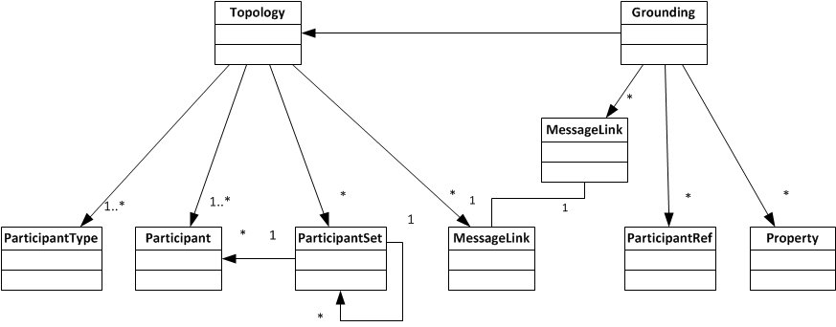

Class Diagram
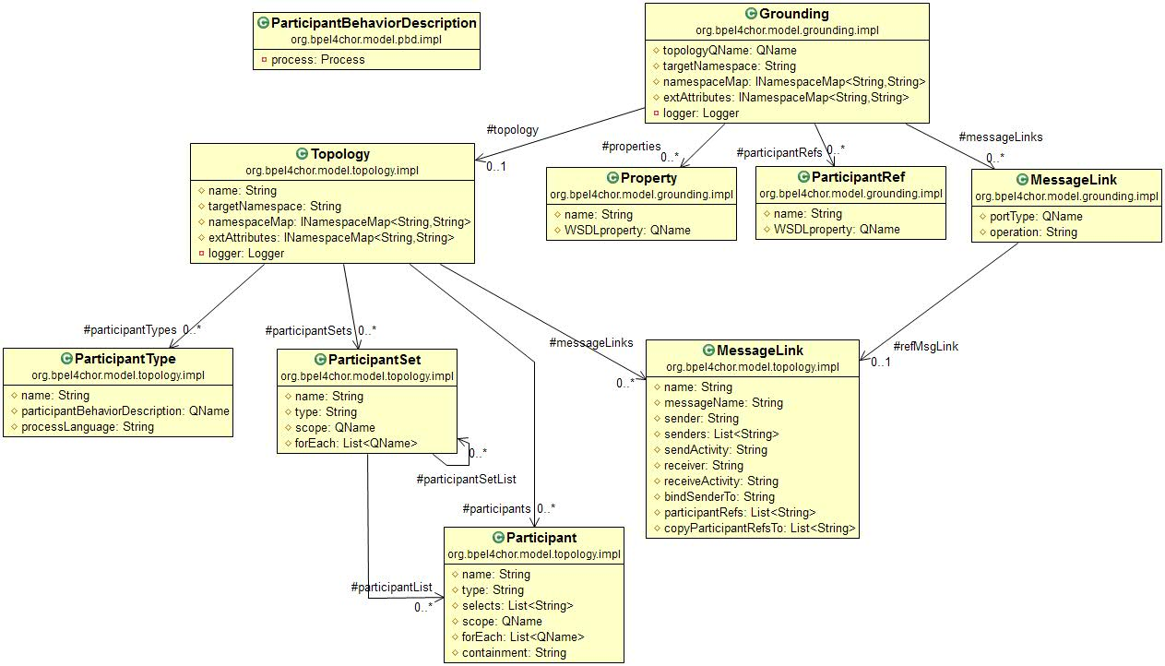

BPEL4Chor Reader and Writer Architecture
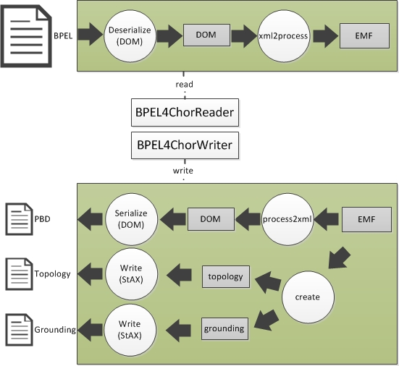
The BPEL4ChorReader for now just reads in the BPEL files and translate it into a BPEL process.
The BPEL4ChorWriter does vice versus, and further more it writes the topology and grounding into file via. StAX.

Note: There is third party solution for print in pretty format for StAX, see e-Mail archive
Email Archive for Pretty Print in StAX
From: "Oliver Kopp" <oliver.kopp@iaas.uni-stuttgart.de>
To: "'Daojun Cui'" <daojun.cui@gmail.com>,
"'Sebastian Wagner'" <sebastian.wagner@iaas.uni-stuttgart.de>
Subject: AW: Meeting Feb. 08. 2012
Date: Thu, 9 Feb 2012 00:15:48 +0100
References

(For staxwriter indent, the first hit pointed to
http://jibx.sourceforge.net/api/org/jibx/runtime/impl/StAXWriter.html#indent
())

For XMLStreamWriter, www.stackoverflow.org was very helpful. I suppose, you
know that site. It has really good tips there!
http://stackoverflow.com/questions/290326/stax-xml-formatting-in-java
http://stackoverflow.com/questions/4616383/xmlstreamwriter-indentation

A cool solution (similar to yours) is:
http://www.ewernli.com/web/guest/47
The difference is that the guy used a Proxy and pushed to code to a separate
class. Then the "normal" code is cleaner!

http://stackoverflow.com/questions/7153221/alternative-to-indentingxmlstream
writer-java
simply recommends "saxon"

BPEL4Chor Utility
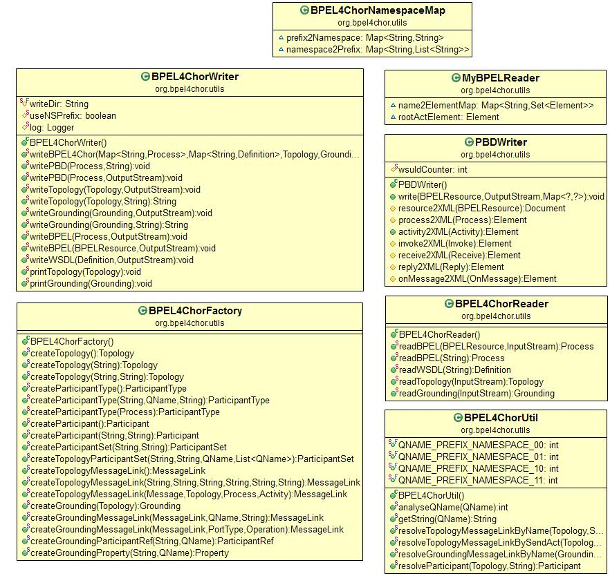

Project Metrics
The project metrics of BPEL4Chor model
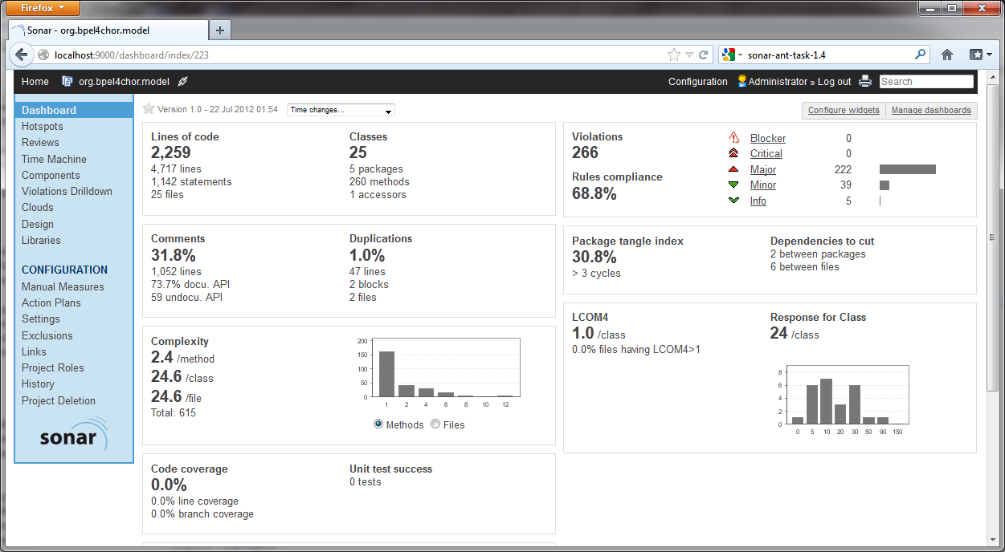

BPEL4Chor Model Test

Project Specification
Project parameter | Specification
Project Name | org.bpel4chor.model.test
Project Type | Test Project
Description | This project provides Unit-Tests for org.bpel4chor.model
Ref. Libraries | JUnit 4, Log4j

Project Metrics
The Project metrics of BPEL4Chor model test
